Learning Journal

Assignment 1-

For my first tutorial I have created a code that allows an object to continuously rotate.

Learning plan-

Task: Create and understand a code that allows objects to rotate in unity.

Step 1- Gain more knowledge of if statements and of input actions to create code

Step 2- Create code that allows object to rotate

Step 3- Create an object to implement code too

Step 4- Using unity software, attach code to object and run, to ensure code works well

|  |  |  |  |  |
| --- | --- | --- | --- | --- |
| Task | Time started | Time finished | Length of any distraction | Time taken to complete |
| Step 1 | 22/10/18  10.30am | 22/10/18  11.05am | 5 Minutes | 30 minutes |
| Step 2 | 22/10/18  11.30am | 22/10/18  11.50am | NONE | 20 Minutes |
| Step 3 | 23/10/18  2.35pm | 23/10/18  2.50pm | 4 Minutes | 11 Minutes |
| Step 4 | 24/10/18  9.30pm | 24/10/18  10pm | NONE | 30 Minutes |

Self assessment:

Overall I feel I have a clear understanding of how programming works and the main function of each unique input in code. However I wanted to research and gain knowledge of anything within the code that I was not completely sure on, or if this was the easiest and simplest code I could use to create a rotation.

Resources:

I will be using the official unity website in order to gain more knowledge of if statements. I already have clear knowledge on how to add an input key function.

Link:

<https://unity3d.com/learn/tutorials/topics/scripting/if-statements>

<https://docs.unity3d.com/ScriptReference/Input.GetKeyDown.html>

**The object**

Here is the object I created in Unity to show how the code effects object movement.

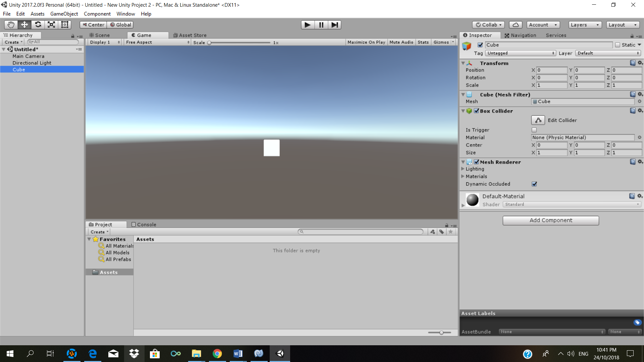

**Code**

using System.Collections;

using System.Collections.Generic;

using UnityEngine;

public class Rotate : MonoBehaviour {

// Use this for initialization

void Start () {

}

void Update () {

if (Input.GetKey (KeyCode.LeftArrow))

transform.Rotate (0, 5, 0);

}

}

Here is the code as shown in the unity software:

